*Laboratory Report*

**INTERNET TECHNOLOGIES LAB.**

**CAP5004L**

**School of Engineering**

**Department of Computer Science and Engineering**

|  |  |
| --- | --- |
| **Submitted By** | |
| **Student Name** | Amit |
| **Roll Number** | 180020307001 |
| **Section/Group** |  |
| **Department** | Computer Science and Engineering |
| **Session/Semester** | 2020-21/ Odd Semester |
| **Submitted To** | |
| **Faculty Name** | Ms. Manka Sharma |



**GD Goenka University**

Sohna road, Gurugram, Haryana

**Table of Content**

|  |  |  |  |
| --- | --- | --- | --- |
| Sl No | Date | Aim of the Experiment | Signature/date |
|  |  |  |  |
|  |  |  |  |
|  |  |  |  |
|  |  |  |  |
|  |  |  |  |
|  |  |  |  |
|  |  |  |  |
|  |  |  |  |
|  |  |  |  |
|  |  |  |  |

|  |  |  |
| --- | --- | --- |
| **Experiment No-6.1** |  | **Date:** |

**Aim of the Experiment:**

Write a JavaScript conditional statement to find the sign of product of three numbers. Display an alert box with the specified sign.

**Source Code - index.html**

<!DOCTYPE html>

<html lang="en">

<head>

<meta charset="UTF-8">

<meta name="viewport" content="width=device-width, initial-scale=1.0">

<title>JS Experiments</title>

</head>

<body>

<script>

var x = 10, y = 20, z = 5;

var product = x * y * z,

sign = '';

sign = product > 0 ? '+' : product === 0 ? 'NaN' : '-';

alert(sign)

</script>

</body>

</html>

**Output**

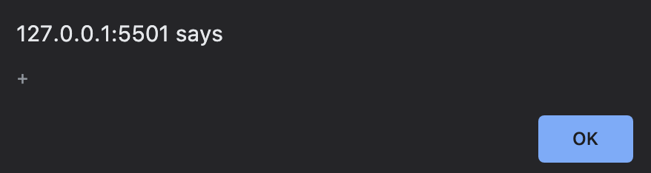

|  |  |  |
| --- | --- | --- |
| **Experiment No-6.2** |  | **Date:** |

**Aim of the Experiment:**

Write a JavaScript program to get the current date. Expected Output : mm-dd-yyyy,

mm/dd/yyyy or dd-mm-yyyy, dd/mm/yyyy.

**Source Code**

<!DOCTYPE html>

<html lang="en">

<head>

<meta charset="UTF-8">

<meta name="viewport" content="width=device-width, initial-scale=1.0">

<title>JS Experiments</title>

</head>

<body>

<p id="date"></p>

<script>

var date = new Date();

var day = date.getDate();

var month = date.getMonth();

var year = date.getFullYear();

document.getElementById('date').innerText = `${month < 10 ? '0' + month : month}-${day < 10 ? '0' + day : day}-${year}, ${month < 10 ? '0' + month : month}/${day < 10 ? '0' + day : day}/${year}`;

</script>

</body>

</html>

**Output**

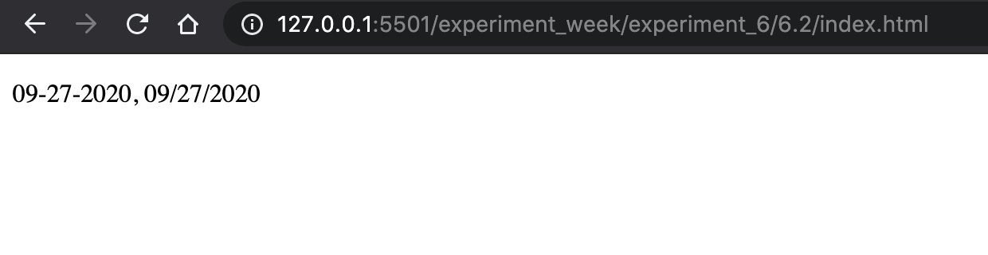

|  |  |  |
| --- | --- | --- |
| **Experiment No-6.3** |  | **Date:** |

**Aim of the Experiment:**

Write a JavaScript conditional statement to find the largest of five numbers. Display an alert box to show the result.

**Source Code**

<!DOCTYPE html>

<html lang="en">

<head>

<meta charset="UTF-8">

<meta name="viewport" content="width=device-width, initial-scale=1.0">

<title>JS Experiments</title>

</head>

<body>

<script>

var a = [1, 2, 3, 4, 5];

var curr_var = 0, brk = false;

var i = j = 0;

for(i = 0; i < a.length; i++) {

curr_var = a[i];

for(j = i + 1; j < a.length; j++) {

if (curr_var < a[j]){

break;

}

if(j === a.length - 1){

brk = true

}

}

if(brk)

break

}

alert(curr_var);

</script>

</body>

</html>

**Output**

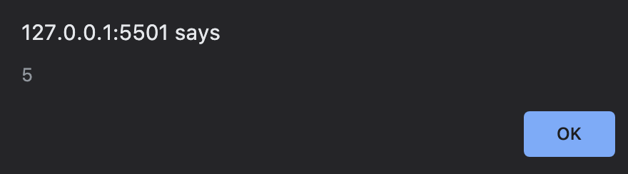

|  |  |  |
| --- | --- | --- |
| **Experiment No-6.4** |  | **Date:** |

**Aim of the Experiment:**

Write a JavaScript program which accepts marks of five subjects and compute the

percentage and grade. The grading criteria will be finalised by the students.

**Source Code**

<!DOCTYPE html>

<html lang="en">

<head>

<meta charset="UTF-8">

<meta name="viewport" content="width=device-width, initial-scale=1.0">

<title>JS Experiments</title>

</head>

<body>

<script>

var a = parseInt(prompt("Soft Computing Marks: "));

var b = parseInt(prompt("Software Process Marks: "));

var c = parseInt(prompt("Minor Project Marks: "));

var d = parseInt(prompt("Artifical Neural Network Marks: "));

var e = parseInt(prompt("Internet Technologies Marks: "));

var p = parseInt( (a + b + c + d + e) / 5);

var grade_json = [

{

grade_name: 'A+',

min: 90,

max: 100

},

{

grade_name: 'A',

min: 80,

max: 90

},

{

grade_name: 'B',

min: 70,

max: 80

},

{

grade_name: 'C',

min: 60,

max: 70

},

{

grade_name: 'D',

min: 40,

max: 60

},

{

grade_name: 'F',

min: 0,

max: 39,

},

]

grade_data = grade_json.filter(data => p >= data.min && p <= data.max)[0];

alert("GRADE: " + grade_data.grade_name);

</script>

</body>

</html>

**Output**

